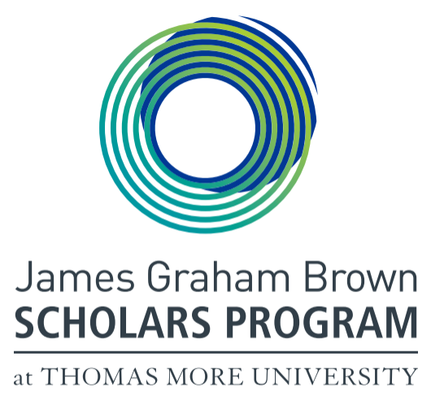
James Graham Brown Scholars Program
2023-4 Information/Application
Current 2023 TMU or transfer students only

Thomas More Students of exceptional academic ability are welcome to apply for admission to the James Graham Brown Scholars Program. Students accepted into the Scholars Program participate in a special program of Scholars seminars, community experience, and the opportunity for advanced research in their majors under the direction of Scholars professors (a Fellowship). This small program not only enhances the educational experience of academically superior students, and can provide them with tuition-free scholarships, but also provides Scholars with exceptional university credentials for future experiences and/or graduate school.

Eligibility
Minimum qualifications to be considered for the JGB Scholars Program are:
- College cumulative GPA of 3.5, with at least 15 semester hours completed at TMU or equivalency at another secondary school;
- Applicants must have at least two years of university left before graduation (rising seniors not eligible).
- Completed application (see form below) which includes:
  - three letters of recommendation (attesting to academic merit and character);
  - written essay;
  - community service.
- Completed and filed Free Application for Federal Student Aid (FASFA) by 31 Jan 2023 (or ASAP; especially for Kentucky residents to access as much Kentucky support as possible).

For all finalists, an on-campus or zoom interview will be conducted on Wednesday 10 May 2023. The JGBS Faculty Committee selects applicants who show the highest scholastic ability based on the above, as well as outstanding character and personal qualities that would enhance the JGBS Program.

To fulfill the James Graham Brown Scholars Program commitment, students must register for at least 15 credits each semester including the Scholars Seminar or Community Service or Internship or Fellowship project.

Scholars must maintain a high quality of performance in written and verbal expression, and critical judgment in all areas of the Scholars Program. They must also maintain a cumulative GPA of 3.5 or better (rounding up is not permitted). Students who do not maintain quality performance or exhibit major deficiencies of character will be removed from the program, subject to the appeal procedures of the University.

The Scholars Program

Thomas More Scholars

Students are initially appointed as Scholars. During this period of the program, students must complete the minimum requirements of two Seminars and one full year (90 hours) of Community Service. Every student must fulfill an obligation to the JGBS Program every semester (Seminar or Service or Internship as detailed below).

Community Service Experience is a social service program based within the University’s service learning mission. Many Scholars participate in the nearby primary school tutoring programs but other Community Service options are available through other Departments. Community Service is possible concurrently with the Seminar or Internship.

JGB Scholars Program students will be expected to participate in all Program activities such as a welcome luncheon, weekend retreats, leadership workshops, lectures, and cultural events.

Thomas More Scholars must complete at least two seminars and an approved Community Service experience (3 credits or equivalent) and have finished the junior year as minimum requirements for advancement to the optional Fellowship level of the program.

Thomas More Fellows

During the second semester of the junior year, Scholars who have completed the minimum requirements of the Scholar’s level (two seminars and one Community Experience) have the option to apply for appointment during their senior year as a Thomas More Fellow. Fellows do not take Seminars or Community Experience, but instead undertake special research in their majors. This senior research must consist of a two-semester, three-credit project approved both by the JGBS Committee and by the Fellow’s department. The research is supervised by a Scholars professor.

Scholars Graduates

Thomas More Fellows receive a special Diploma noting the Fellowship.

All James Graham Brown Scholars and Fellows, and all professors, become life-members of the James Graham Brown Scholars Society, which meets annually to reunite the graduates of the Program in social activities and service projects.

Updated Feb 2023 ces
James Graham Brown Scholars Program
Current/Transfer Students Only (please print)

First Name: ____________________________ Last Name: _____________________________

Home Address: Street: ______________________________ City: _______________________

State: ____ Zip: __________ Telephone (____) ___________

Email address: __________________________________

Current level (circle one; juniors ineligible to apply): First-year Sophomore

GPA _________ ACT (advisory only) _______ Current major __________________________________

* * * * * * * * * * * * * * * * * * * * * * *
Please enclose with this application the following and return to Dr. Catherine Sherron, no later than 5:00 P.M. Monday, 3 April 2023 (but complete FASFA ASAP):

Completed application submission. All components except for the application form should be emailed directly to JGBS@thomasmore.edu .
- This JGBS application form.
- Three letters of recommendation (attesting to academic merit and character)
Please request from three persons, preferably your professors, letters supporting your candidacy. Letters should attest to your academic abilities and/or your character. These letters are to be emailed directly by your reference to the Committee at JGBS@thomasmore.edu
- Two-minute audio or video self-interview discussing:
  - something you’re proud of (leadership, creativity, service, or other significant accomplishment) OR
  - something either you had to give up to achieve academically or something desirable you were not able to have due to other significant commitments (family, academics, sports).
  - Please send a link (not the video itself) to JGBS@thomasmore.edu. We recommend this brief instructional video as well: https://youtu.be/6C4dEpT0rYg
- Academic transcript (unofficial TMU transcript from Registrar is acceptable; official from other schools).
- Two page maximum blind application essay (prompt below).
- Chart listing significant community service (fill in chart below).

Please note that all finalists will be asked to participate in an interview (preferably in person, but Zoom is possible) on Wednesday 10 May 2023. You should expect to hear about an interview no later than 5 May.

Your Signature: __________________________________ Date of Submission _______________________

Notification of Committee decisions is made late-May. You may contact Dr. Sherron in her Philosophy Department office, by phone 859-344-3387, or by e-mail (sherroc@thomasmore.edu). Throughout the application process, you should check your e-mail for acknowledgements and questions from her.
James Graham Brown Scholars Program
Scholarship Essay

Essays are evaluated anonymously and should not have your name on it.
.

Essay Prompt

Reflecting on your time at TMU and our mission:
Thomas More University is the Catholic Liberal Arts University of the Diocese of Covington, Kentucky. Inspired by the Catholic Intellectual Tradition, we challenge students of all faiths to examine the ultimate meaning of life, their place in the world, and their responsibility to others.
If you were part of a group that was going to create a signature event for TMU, what would it be? Describe the event, including the involvement of students, faculty, staff, and any external partners you choose. How would your event help deepen all students’ understanding of our Mission? How could it strengthen ties across TMU constituents? How might it help people outside TMU, particularly those who are not Catholic, those who did not attend university, and those who did not grow up in the greater Cincinnati region, understand our purpose and Mission?

In 750-1000 words, please reflect on this creative exploration of our Mission. Your well-crafted and polished essay should reflect your own original thinking with no or minimal references to outside sources; your audience consists of college professors. There is no right or wrong answer – we are genuinely interested in your honest response and how well you address this hypothetical opportunity.

Service Chart

Fill out the chart below listing your top 15 service experiences completed during college. Most recent on top of chart. Give priority to significant service which includes a long-term commitment with one organization or a concentrated effort (such as a full-weekend service retreat).

Organization | # of Completed Hours  Total time spent while  in college. | Recurring?  (Yes or No) | If Recurring,  # of hours and frequency  (e.g., weekly, monthly, etc.)

